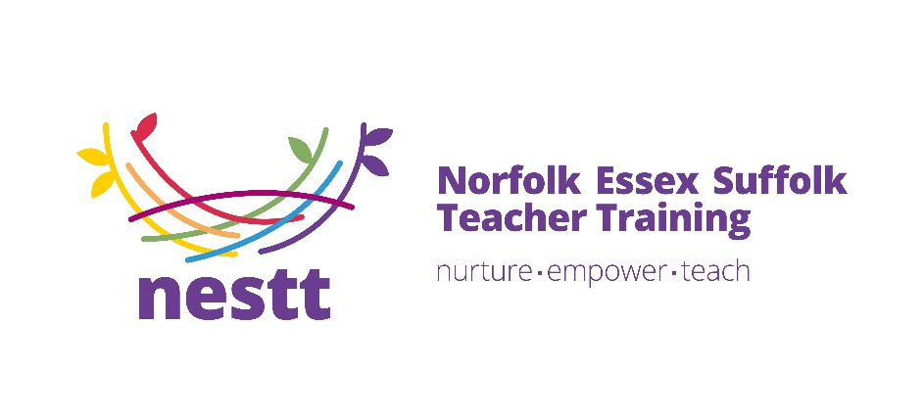

Teaching is an incredibly rewarding career – and it is important to have the best quality training to start you on your professional journey. We are proud to work in partnership with NESTT to offer placements for trainee teachers at our school.

Why Train with NESTT?

1. A Track Record of Success

NESTT is formed from a merger of two well-established school-based teacher training providers who between them have over 50 years of experience of successful teacher training in the East of England.

1. High Quality Face to Face Training

Our training course is the perfect combination of theoretical knowledge and practical experience ensuring you get enjoyment and satisfaction from your new career.

1. A Personalised Programme

Our locally-based teams will continue to build on existing relationships with schools to meet individual trainee needs and personalise the training journey.

1. A Wide Range of Placements

We work with over 200 local schools across East Anglia so we are able to offer you a wide range of placements in a school that is local to you.

1. Rapid Career Development

The vast majority of our trainees take up positions in our local schools. Our high-quality training is fully aligned with the Early Career Framework so our trainees get a flying start, many of them enjoying accelerated career development.

To find our more and book into a recruitment information event visit <https://nestt.org.uk/>